Assignment 11. – Nonfunctional Testing
Selenium WebDriver is primarily used to assess the functional requirements of web applications. In other words, testers use the Selenium WebDriver API to verify that a web application under test behaves as expected. Nevertheless, we can leverage this API to test nonfunctional requirements, i.e., quality attributes such as performance, security, accessibility, etc. A common strategy to accomplish this goal is to integrate with specific third-party utilities. The following subsections explain different integrations with Selenium WebDriver for nonfunctional testing.

Performance
Performance testing evaluates the responsiveness and stability of a SUT under a particular workload. Instead of Selenium WebDriver, testers usually adopt specific tools like Apache JMeter for performance testing. Apache JMeter is an open source tool that allows sending multiple HTTP requests to a given URL endpoint while measuring the response time and other metrics. Although the direct integration between Selenium WebDriver and Apache JMeter is not trivial, we can leverage an existing Selenium WebDriver test as a JMeter test plan (i.e., the series of steps that JMeter executes). The benefit of this approach is that the resulting JMeter test plan will mimic the same user workflow used in the Selenium WebDriver test, reusing the same HTTP traffic the browser makes (e.g., for JavaScript libraries, CSS, etc.). To that aim, I propose the following procedure:
- Use the BrowserMob proxy (introduced in the previous section) to capture the exchanged network traffic in Selenium WebDriver as a HAR file.
- Convert the resulting HAR file to a JMeter test plan. Test plans in JMeter are stored as XML-based files with the extension JMX.
- Load the JMX test plan in JMeter and tune it for simulating concurrent users and including result listeners
- Run the test plan and evaluate the results.
Example 5 shows a complete test case that implements the first step. As you can see, the required login to start and create the HAR file is done before and after each test. You can use this approach to leverage existing functional tests (i.e., the logic in the @Test methods) as performance tests (to be executed in JMeter).
Example 5. Test creating a HAR file
class HarCreatorJupiterTest {

WebDriver driver;

BrowserMobProxy proxy;

@BeforeEach
void setup() {
proxy = new BrowserMobProxyServer();
proxy.start();
proxy.newHar();
proxy.enableHarCaptureTypes(CaptureType.REQUEST_CONTENT, CaptureType.RESPONSE_CONTENT);

Proxy seleniumProxy = ClientUtil.createSeleniumProxy(proxy);
ChromeOptions options = new ChromeOptions();
options.setProxy(seleniumProxy);
options.setAcceptInsecureCerts(true);

driver = WebDriverManager.chromedriver().capabilities(options).create();
}

@AfterEach
void teardown() throws IOException {
Har har = proxy.getHar();
File harFile = new File("login.har");
har.writeTo(harFile);

proxy.stop();
driver.quit();
}

@Test
void testHarCreator() {
driver.get("https://bonigarcia.dev/selenium-webdriver-java/login-form.html");

driver.findElement(By.id("username")).sendKeys("user");
driver.findElement(By.id("password")).sendKeys("user");
driver.findElement(By.cssSelector("button")).click();
String bodyText = driver.findElement(By.tagName("body")).getText();
assertThat(bodyText).contains("Login successful");
}
}

We start BrowserMob before the test and configure it in the WebDriver session.
We get the HAR file after the test and write it as a local file.

After running the previous test, we get a HAR file called login.har. Now, we need to convert it to a JMeter test plan. There are different alternatives to do that. You can find several programs (e.g., in Ruby or Java) that make this job freely available on the web. Also, you can use online converters services, such as the BlazeMeter JMX Converter. In this example, I use this online service and open the resulting JMX test plan in JMeter. At this point, you can tune the JMeter configuration at your convenience (you can find further information about JMeter in its official user manual). For instance, Figure 2 shows the JMeter GUI after loading the resulting JMX test plan plus the following changes:
- Increase the number of concurrent users to one hundred (in the “Thread Group” tab)
- Include some result listeners, such as “Aggregate Graph” and “Graph Results
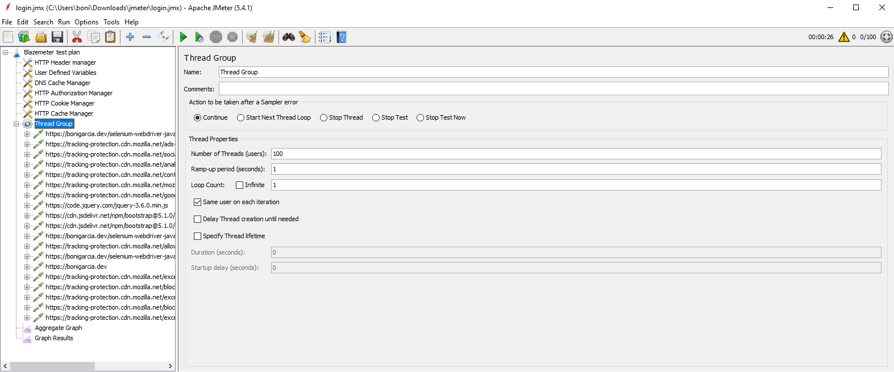
Figure 2. JMeter GUI loading the resulting test plan
Now, we can run the test plan with JMeter (for example, clicking on the button with a green triangle in the JMeter GUI). As a result, a load of one hundred concurrent users is generated following the interactions initially developed as a Selenium WebDriver test (Example 5). Figure 3 shows the results for the previously added listeners.
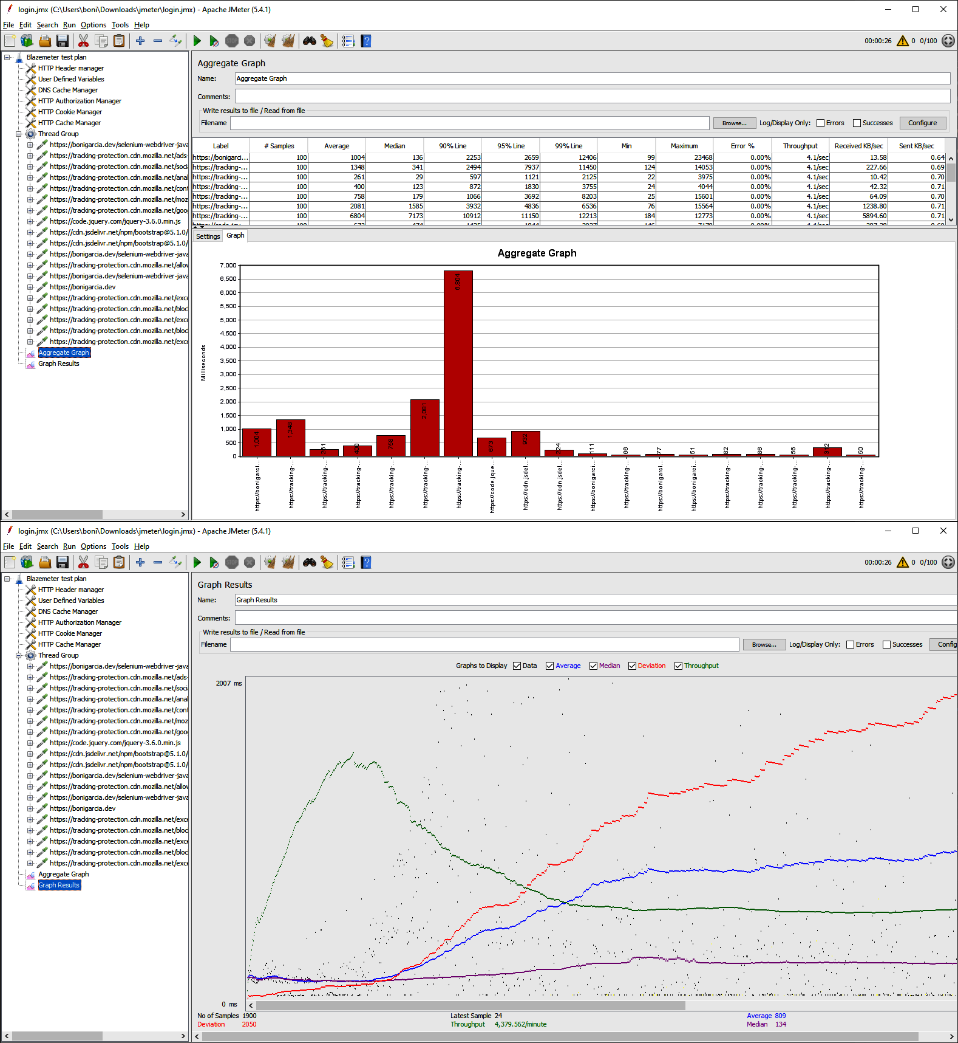
Figure 3. JMeter results

Using browsers to generate the load
Using tools like JMeter is convenient for many performance testing scenarios for web applications. Nevertheless, this approach is unsuitable when you need actual browsers to recreate the complete user workflow (e.g., in videoconferencing web apps). In that case, a possible solution is to use WebDriverManager in conjunction with Docker. Example 6 demonstrates this use. As you can see in this test, WebDriverManager allows creating a list of WebDriver instances simply by specifying the size as a parameter in the create() method. Then, for example, we can use standard Java to exercise the web application under test in parallel using a thread pool.
Example 6. Load test using WebDriverManager and Docker
class LoadJupiterTest {

static final int NUM_BROWSERS = 5;

final Logger log = getLogger(lookup().lookupClass());

List<WebDriver> driverList;

WebDriverManager wdm = WebDriverManager.chromedriver().browserInDocker();

@BeforeEach
void setupTest() {
assumeThat(isDockerAvailable()).isTrue();
driverList = wdm.create(NUM_BROWSERS);
}

@AfterEach
void teardown() {
wdm.quit();
}

@Test
void testLoad() throws InterruptedException {
ExecutorService executorService = newFixedThreadPool(NUM_BROWSERS);
CountDownLatch latch = new CountDownLatch(NUM_BROWSERS);

driverList.forEach((driver) -> {
executorService.submit(() -> {
try {
checkHomePage(driver);
} finally {
latch.countDown();
}
});
});

latch.await(60, SECONDS);
executorService.shutdown();
}

void checkHomePage(WebDriver driver) {
log.debug("Session id {}", ((RemoteWebDriver) driver).getSessionId());
driver.get("https://bonigarcia.dev/selenium-webdriver-java/");
assertThat(driver.getTitle()).contains("Selenium WebDriver");
}
}

We create an instance of the Chrome manager, using Docker to execute the browsers as containers.
We assume that Docker is installed in the machine running this test. Otherwise, the test is skipped.
We create a WebDriver list (containing five instances in this example).
We create a thread pool using the same size as the WebDriver list.
We use the thread pool to execute in parallel the SUT assessment.
We wait until each parallel evaluation finishes. We use a synchronization method based on a counter latch to do that.

Security
A relevant organization in the software security domain is OWASP (Open Web Application Security Project), a nonprofit foundation that promotes open solutions to improve software security. One of the most popular OWASP projects is the Zed Attack Proxy (ZAP). OWASP ZAP is an open source web application security scanner used to implement vulnerability assessment (i.e., look for security issues) or penetration testing (i.e., a simulated cyberattack) to find exploitable web application vulnerabilities.
We can use OWASP ZAP as a standalone desktop application. Figure 4 shows a screenshot of its GUI.
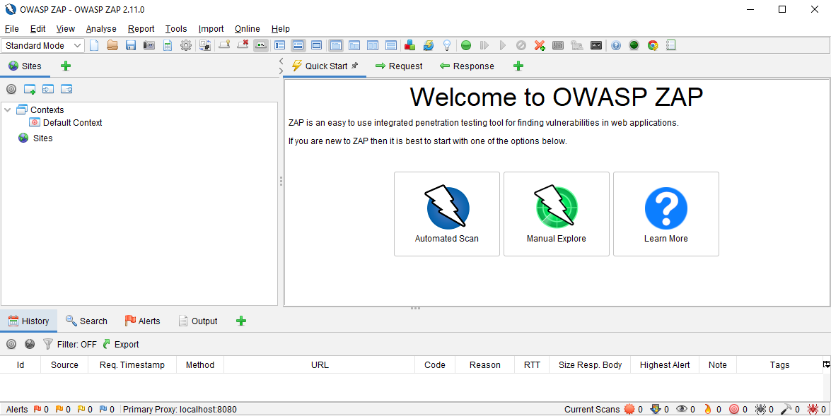
Figure 4. OWASP ZAP GUI
This GUI provides different features for automated scans to detect security threats that a web application might face, such as SQL injection, cross-site scripting (XSS), or cross-site request forgery (CSRF), to name a few.
In addition to the standalone application, we can integrate a Selenium WebDriver test with ZAP. Example 7 provides a test case illustrating this integration. The steps required to execute this test properly are:
- Start OWAS ZAP in the localhost. By default, OWASP starts a proxy that listens to port 8080. You can change this port using the OWASP GUI using the menu option Tools → Options → Local Proxies.
- Disable the API key (or copy its value in the Selenium WebDriver test). You can change this value in the menu option Tools → Options → API.
- Implement a Selenium WebDriver test that uses OWASP ZAP as a proxy (like Example 7).
- Execute the Selenium WebDriver test. At this point, you should see the generated vulnerability report in the ZAP GUI.
Example 7. Test using OWASP ZAP as security scanner
class SecurityJupiterTest {

static final Logger log = getLogger(lookup().lookupClass());

static final String ZAP_PROXY_ADDRESS = "localhost";
static final int ZAP_PROXY_PORT = 8080;
static final String ZAP_API_KEY = "<put-api-key-here-or-disable-it>";

WebDriver driver;

ClientApi api;

@BeforeEach
void setup() {
String proxyStr = ZAP_PROXY_ADDRESS + ":" + ZAP_PROXY_PORT;
assumeThat(isOnline("http://" + proxyStr)).isTrue();

Proxy proxy = new Proxy();
proxy.setHttpProxy(proxyStr);
proxy.setSslProxy(proxyStr);

ChromeOptions options = new ChromeOptions();
options.setAcceptInsecureCerts(true);
options.setProxy(proxy);

driver = WebDriverManager.chromedriver().capabilities(options).create();

api = new ClientApi(ZAP_PROXY_ADDRESS, ZAP_PROXY_PORT, ZAP_API_KEY);
}

@AfterEach
void teardown() throws ClientApiException {
if (api != null) {
String title = "My ZAP report";
String template = "traditional-html";
String description = "This is a sample report";
String reportfilename = "zap-report.html";
String targetFolder = new File("").getAbsolutePath();
ApiResponse response = api.reports.generate(title, template, null,
description, null, null, null, null, null, reportfilename,
null, targetFolder, null);
log.debug("ZAP report generated at {}", response.toString());
}
if (driver != null) {
driver.quit();
}
}

@Test
void testSecurity() {
driver.get("https://bonigarcia.dev/selenium-webdriver-java/web-form.html");
assertThat(driver.getTitle()).contains("Selenium WebDriver");
}
}

We configure the address and port where the ZAP local proxy is listening.
If the ZAP API key is not disabled, we need to set its value here.
We configure ZAP as a Selenium WebDriver proxy.
We interact with ZAP using its API.
After the test, we create an HTML report with vulnerabilities found during the execution of the Selenium WebDriver test. Figure 5 shows a screenshot of this report.
NOTE
We can also use OWASP ZAP as a standalone GUI, as introduced previously. The potential benefit of the integration with Selenium WebDriver could be reusing existing functional tests for assessing security or automated security assessment (e.g., a regression test suite executed by a CI server).
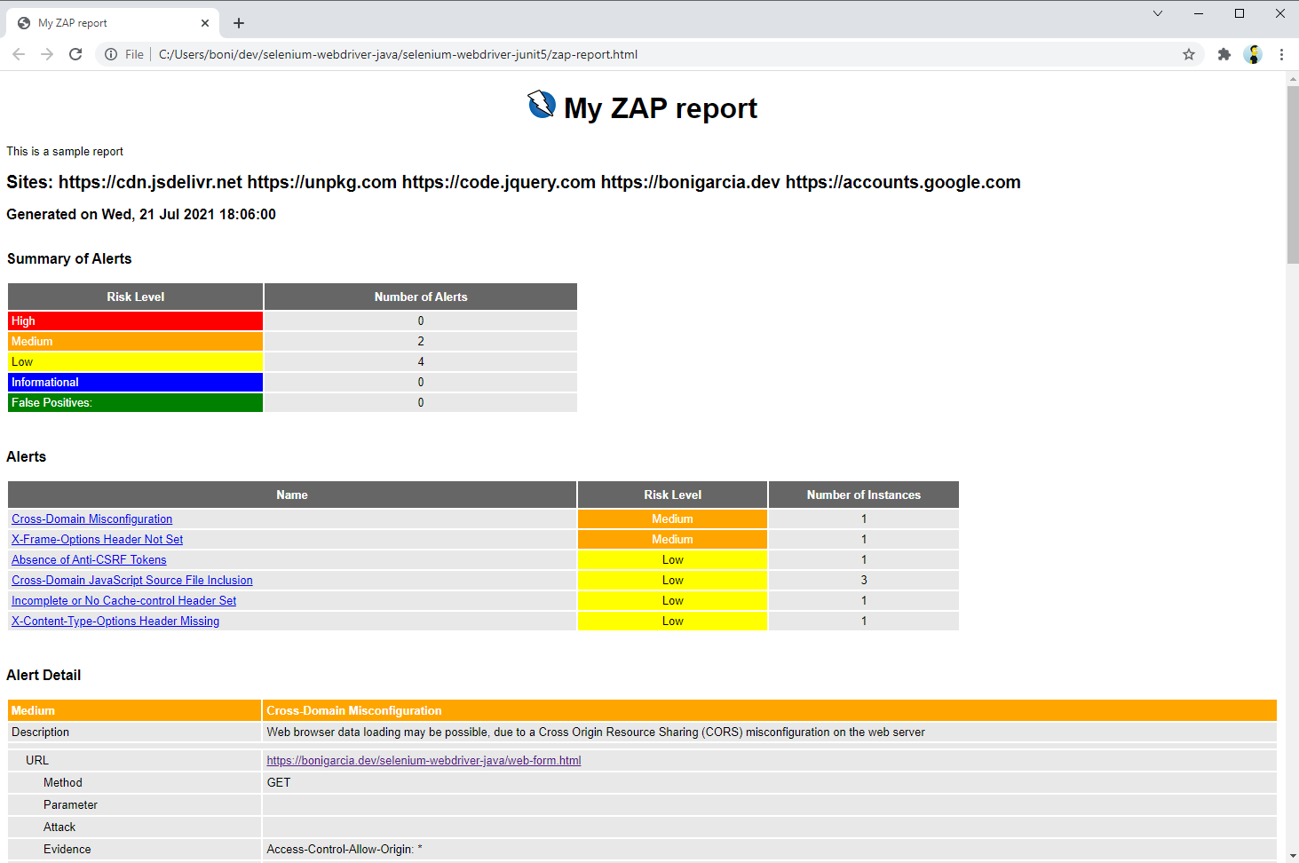
Figure 9-5. Report generated by ZAP after executing a Selenium WebDriver test

Accessibility
Digital accessibility refers to the ability of users with disabilities to effectively use software systems such as websites, mobile apps, etc. An essential reference in this domain is the Web Content Accessibility Guidelines (WCAG), which are a set of standard recommendations created by the W3C Web Accessibility Initiative (WAI) that explain how to make web content more accessible to people with disabilities.
There are several methods to test the accessibility of web applications. The most common approach consists of checking the WCAG recommendations. To that aim, we can use automated accessibility scanners like Axe, an open source engine for automated accessibility testing of web applications following WCAG rules. Axe provides seamless integration with the Java bindings of Selenium WebDriver using a helper library. Example 8 shows a test using this library.
Example 9-8. Test using Axe to generate an accessibility report
@Test
void testAccessibility() {
driver.get("https://bonigarcia.dev/selenium-webdriver-java/");
assertThat(driver.getTitle()).contains("Selenium WebDriver");

Results result = new AxeBuilder().analyze(driver);
List<Rule> violations = result.getViolations();
violations.forEach(rule -> {
log.debug("{}", rule.toString());
});
AxeReporter.writeResultsToJsonFile("testAccessibility", result);
}

We analyze the current WebDriver session with Axe. This way, all pages loaded in the browser will be scanned by Axe.
We get a report of the accessibility violations found.
We log each violation in the standard output. In this example, the found issues are:
color-contrast Elements must have sufficient color contrast.
heading-order Heading levels should only increase by one.
image-alt Images must have alternate text.
link-name Links must have discernible text.
We write the results as a local JSON file.

A/B Testing
A/B testing is a form of usability evaluation that compares variations of the same application to discover which one is more effective to its end users. Different commercial products facilitate advanced features for A/B tests in Selenium WebDriver tests. For example, Applitools Eyes provides an automated visual comparison of multiple web page variations. Another option is Optimizely, a company that provides tools for customizing and experimenting with A/B testing.
Another way to carry out A/B testing is to use the vanilla Selenium WebDriver API and custom conditions for the different variations of a web page. Example 9 shows a basic test following a manual approach for a multivariant web page. Notice that this test shows a simple way to implement an A/B test based on assessing the different page variations.
Example 9. Basic A/B test using Selenium WebDriver
@Test
void testABTesting() {
driver.get("https://bonigarcia.dev/selenium-webdriver-java/ab-testing.html");
WebDriverWait wait = new WebDriverWait(driver, Duration.ofSeconds(10));
WebElement header = wait.until(ExpectedConditions.presenceOfElementLocated(By.tagName("h6")));

if (header.getText().contains("variation A")) {
assertBodyContains(driver, "Lorem ipsum");
} else if (header.getText().contains("variation B")) {
assertBodyContains(driver, "Nibh netus");
} else {
fail("Unknown variation");
}
}

void assertBodyContains(WebDriver driver, String text) {
String bodyText = driver.findElement(By.tagName("body")).getText();
assertThat(bodyText).contains(text);
}

We open a multivariant practice web page. The content of this page is randomly loaded 50% of the time.
We check the page variations are as expected.

Fluent API
Selenium is the foundation technology for other frameworks and libraries. For instance, we can find several libraries wrapping Selenium WebDriver to expose a fluent API for creating end-to-end tests for web applications. An example of this kind of library is Selenide, an open source (MIT license) library that defines a concise fluent API on top of Selenium WebDriver. Selenide provides several benefits, such as automated waiting for web elements or support for AJAX applications.
A relevant difference of a Selenide test compared to Selenium WebDriver is that Selenide handles the WebDriver objects internally. For that, it uses WebDriverManager to resolve the required driver (e.g., chromedriver, geckodriver, etc.), holding the WebDriver instance in a separate thread that is closed at the end of the test. As a result, the required test boilerplate related to the creation and termination of WebDriver objects is not required. Example 10 demonstrates this feature by showing a basic Selenide test.
Example 10. Test using Selenide
class SelenideJupiterTest {

@Test
void testSelenide() {
open("https://bonigarcia.dev/selenium-webdriver-java/login-form.html");

$(By.id("username")).val("user");
$(By.id("password")).val("user");
$("button").pressEnter();
$(By.id("success")).shouldBe(visible).shouldHave(text("Login successful"));
}
}
We use the static method open provided by Selenide to navigate a given URL. By default, Selenide uses a local Chrome, although the browser can be changed using a configuration class (e.g., Configuration.browser = "firefox";) or using a Java system property (e.g., -Dselenide.browser=firefox).
The Selenide method $ allows you to locate web elements by CSS selector or using Selenium WebDriver By locators. This line of code uses the latter to type text into an input field.
We locate another web element, this time by CSS selector, and click on it.
We verify that the web element for successful login is present on the page and contains the expected text.

Test Data
A relevant part of any test case is the test data, i.e., the input data used to exercise the SUT. The selection of suitable test data is paramount for implementing effective tests. Differing techniques in classic testing theory for test data selection include:
Equivalence partitioning
The process of testing by dividing all possible input test data into value sets that we assume to be processed in the same way.
Boundary testing
The process of testing between extreme ends or between partitions of the input values. The basic idea of this approach is to select the representative limit values in an input domain (for example, below the minimum, minimum, just above the minimum, nominal, just below the maximum, maximum, and above the maximum value).
These approaches can be impractical in end-to-end testing since the required number of tests (and the resulting execution time) to carry out these strategies can be enormous. Alternatively, we typically select some representative test data manually to verify the happy path (i.e., positive testing), and optionally, some test data for unexpected conditions (negative testing).
Another alternative for selecting test data is using fake data, i.e., random data of different domains, such as personal names, surnames, addresses, countries, emails, phone numbers, etc. A simple alternative to this aim is using Java Faker, a port of the popular faker Ruby gem. Example 11 shows a test using this library. This test uses fake data to submit a web form available on the practice site. Figure 6 shows this web page after submitting the form with that fake data.
Example 11. Test using Java Faker to generate different types of fake data
@Test
void testFakeData() {
driver.get("https://bonigarcia.dev/selenium-webdriver-java/data-types.html");

Faker faker = new Faker();

driver.findElement(By.name("first-name"))
.sendKeys(faker.name().firstName());
driver.findElement(By.name("last-name")).sendKeys(faker.name().lastName());
driver.findElement(By.name("address")).sendKeys(faker.address().fullAddress());
driver.findElement(By.name("zip-code")).sendKeys(faker.address().zipCode());
driver.findElement(By.name("city")).sendKeys(faker.address().city());
driver.findElement(By.name("country")).sendKeys(faker.address().country());
driver.findElement(By.name("e-mail")).sendKeys(faker.internet().emailAddress());
driver.findElement(By.name("phone")).sendKeys(faker.phoneNumber().phoneNumber());
driver.findElement(By.name("job-position")).sendKeys(faker.job().position());
driver.findElement(By.name("company")).sendKeys(faker.company().name());

driver.findElement(By.tagName("form")).submit();

List<WebElement> successElement = driver.findElements(By.className("alert-success"));
assertThat(successElement).hasSize(10);

List<WebElement> errorElement = driver.findElements(By.className("alert-danger"));
assertThat(errorElement).isEmpty();
}
We create an instance of Java Faker.
We send random data of different types (name, address, country, etc.).
We verify that the data is submitted correctly.
We check there are no errors on the page.

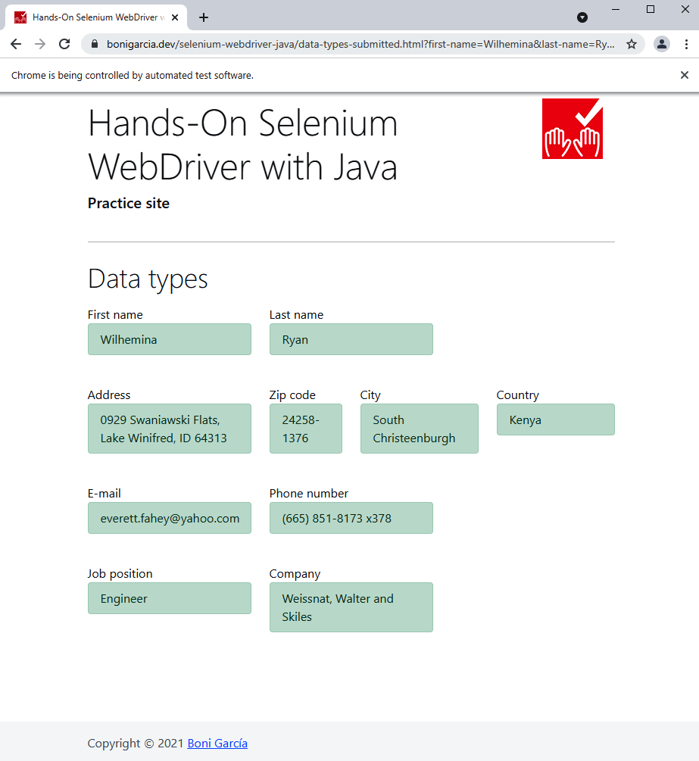
Figure 6. Practice page using fake data

Reporting
A test report is a document that summarizes the results after executing a test suite. This document typically contains the number of tests executed plus their verdicts (pass, fail, skip) and execution time. There are different ways to obtain a test report in our Java project. For example, when using Maven, we can create a basic test report using the following commands:
mvn test
mvn surefire-report:report-only
mvn site -DgenerateReports=false
We execute the test with Maven. As a result, the Maven Surefire plug-in generated a set of XML files in the target folder. These files contain the results of the test execution.
We convert the XML reports into an HTML report. You can find this HTML report in your project folder target/site.
We force a copy of the CSS and images required in the HTML report. Figure 7 shows a screenshot of this report.
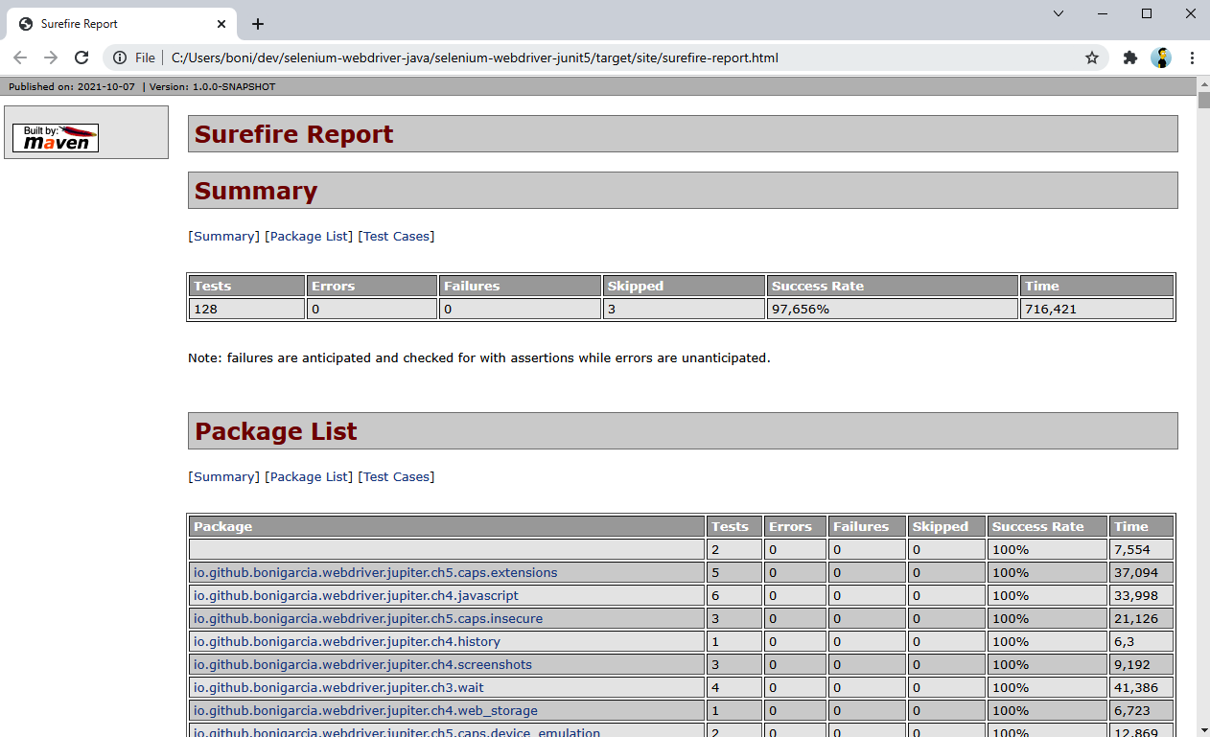
Figure 7. Test report generated with Maven
We can also generate an equivalent report using Gradle. After executing a test suite with this build tool, Gradle automatically generates an HTML report in the folder build/reports. Figure 8 shows an example of the test report generated for executing a group of tests (using the shell command gradle test --tests Hello*).
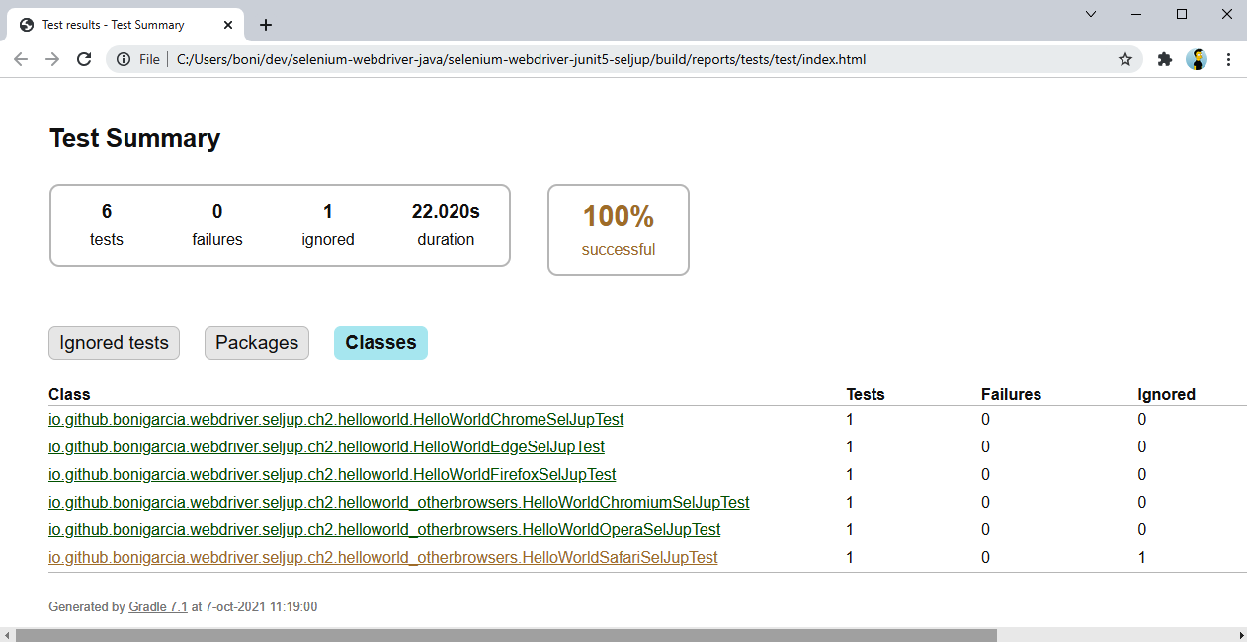
Figure 9-8. Test report generated with Gradle
In addition to Maven and Gradle, we can use existing reporting libraries to create richer reports. A possible alternative is Extent Reports, a library to create interactive test reports. Extent Reports provides professional (commercial) and community (open source) editions. Example 12 shows a test using the latter.
Example 12. Test using Extent Reports to generate an HTML report
class ReportingJupiterTest {

WebDriver driver;

static ExtentReports reports;

@BeforeAll
static void setupClass() {
reports = new ExtentReports();
ExtentSparkReporter htmlReporter = new ExtentSparkReporter("extentReport.html");
reports.attachReporter(htmlReporter);
}

@BeforeEach
void setup(TestInfo testInfo) {
reports.createTest(testInfo.getDisplayName());
driver = WebDriverManager.chromedriver().create();
}

@AfterEach
void teardown() {
driver.quit();
}

@AfterAll
static void teardownClass() {
reports.flush();
}

// Test methods

}
We create an instance of the test reporter.
We configure it to generate an HTML report.
After each test, we create an entry in the test report using the test name as an identifier. In JUnit 5, we use TestInfo, a built-in parameter resolver that allows retrieving information about the current test.
In particular, this class has two test methods. Figure 9 shows the resulting test report generated when this test class is executed.
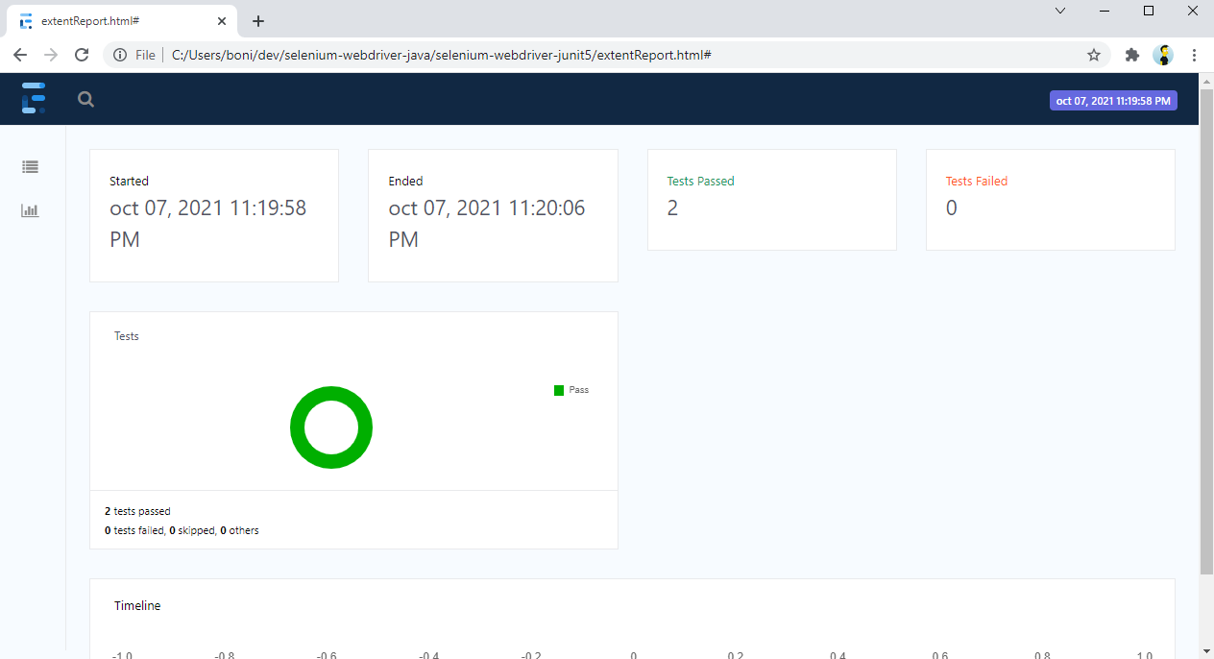
Figure 9. Test report generated with Extent Reports
An inconvenience of Extent Reports is that we need to add each test explicitly to the reporter. A possible solution to this problem is using custom test listeners) to group the common logic for reporting.
Another possible library for generating rich test reports is Allure, an open source reporting framework for generating test reports for different programming languages, including Java, Python, and JavaScript, among others. A notable difference between Allure and Extent Reports is that Allure uses a test listener configured in the build tool Maven or Gradle. This way, we did not need to change our test suite for generating Allure reports. Table 1 summarizes the necessary commands to create Allure reports with Maven and Gradle.
Maven | Gradle | Description
mvn test | gradle test | Run test cases
mvn allure:report | gradle allureReport | Create the reports on the target folder
mvn allure:serve | gradle allureServe | Open the HTML report using a local web server
Table 1. Maven and Gradle commands to generate test reports with Allure
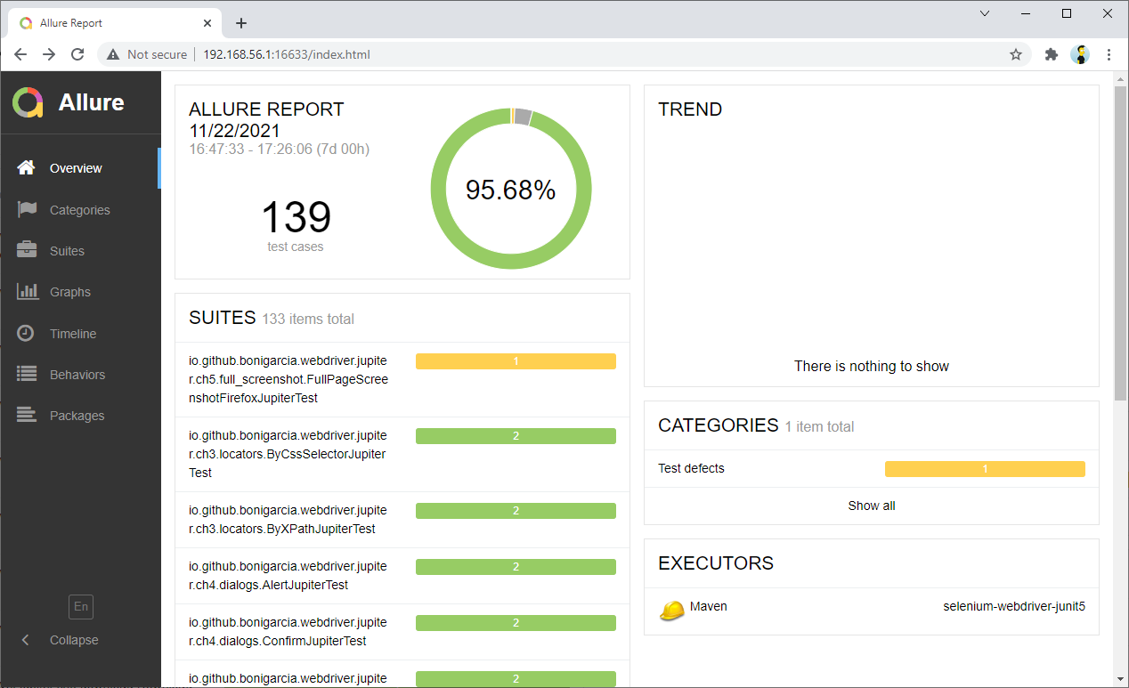
Figure 9-10. Test report generated with Allure and served locally

Summary and Outlook
This assignment provided a practical overview for integrating different technologies (such as tools, libraries, and frameworks) in the development of end-to-end tests for web applications with Selenium WebDriver. First, we used Awaitility (a library to handle asynchronous operations) for waiting until files are downloaded with Selenium WebDriver. An alternative library to execute the same use case (i.e., downloading files) is Apache HttpClient. Then, we used the BrowserMob proxy to intercept the HTTP traffic exchanged by a Selenium WebDriver test. The next group of technologies focused on enabling nonfunctional testing with Selenium WebDriver: BrowserMob (to create a JMeter test plan for performance testing), OWASP ZAP (for security testing), and Axe (for accessibility testing). Then, we used the fluent API provided by Selenide, Java Faker, to create fake test data for Selenium WebDriver tests, and Extent Reports and Allure to generate rich test reports. Finally, we discovered how to integrate Cucumber (a BDD framework) and Spring (a Java and web framework) with Selenium WebDriver.

